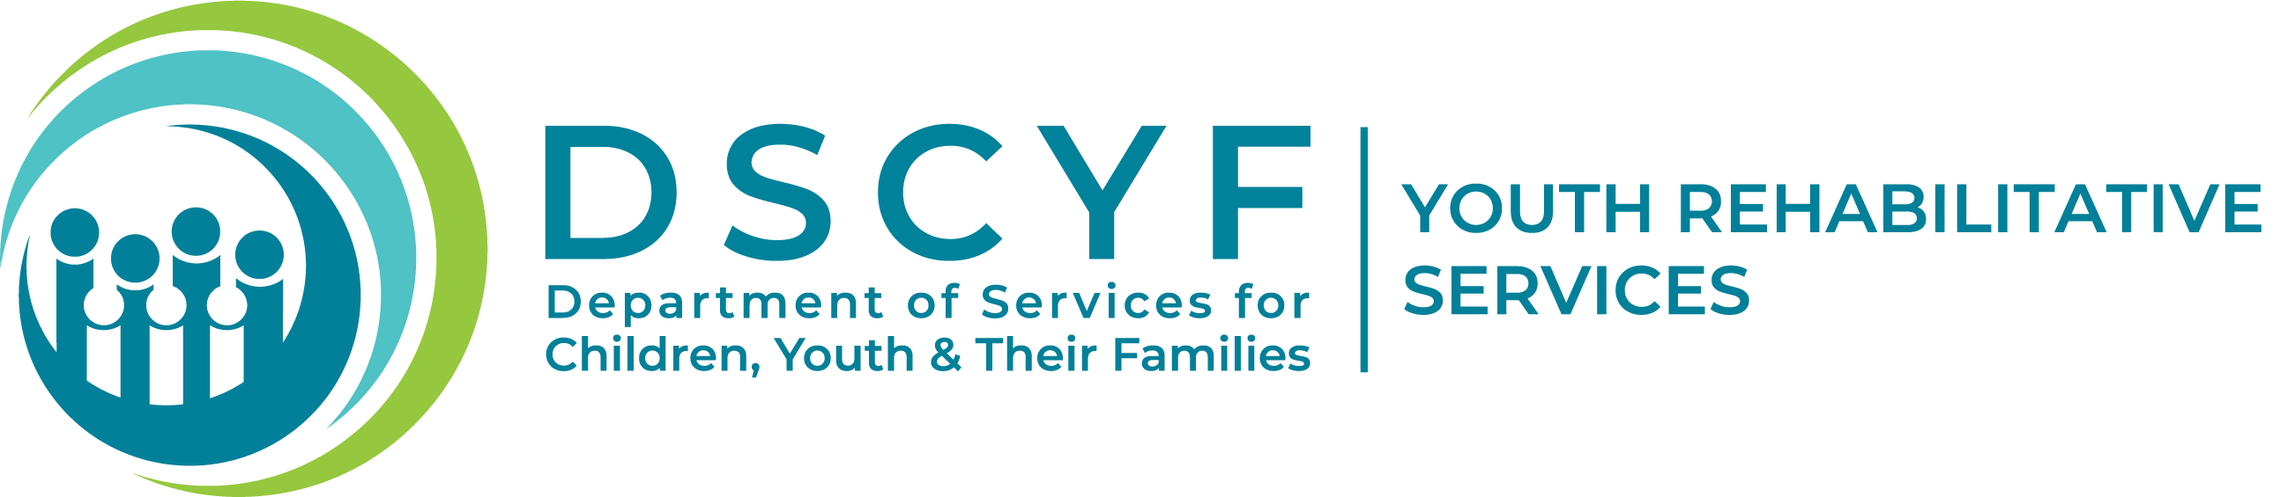
DYRS Program Review Committee
Program Submission Form

All programs must provide the following information at least 5 working days prior to the scheduled Program Review Committee (PRC) meeting to YRS.DSCYF@delaware.gov. Please be sure to provide a curriculum or lesson plans for review. The coordinator/presenter must be present at the PRC meeting to provide information about the program and answer questions. Please note that everyone who provides programming for DYRS youth must successfully complete a background check process.
- Title of the program
Click or tap here to enter text.

- Contact person, phone, and email
Click or tap here to enter text.

- How did you find out about us?
Click or tap here to enter text.

- Do you have a Delaware business license?
Yes☐ No☐

- What facility/site is the program being proposed for?
Ferris School ☐ Stevenson House Detention Center ☐
Grace Cottage ☐ New Castle County Detention Center ☐
Snowden Cottage ☐ DYRS Community Services ☐

- What is the purpose of the program?
Click or tap here to enter text.

- What is the proposed start date?
Click or tap to enter a date.

- Who is the target population?

  - What are the criteria for participation (age/gender/IQ/other criteria)?
Click or tap here to enter text.
  - Who would be excluded and why?
Click or tap here to enter text.
  - Approximately how many youth will be involved?
Click or tap here to enter text.

- What is needed from DYRS staff for implementation of the program?
Click or tap here to enter text.

- What materials are associated with the program?
Click or tap here to enter text.

- What is the proposed cost of the program?
Click or tap here to enter text.

- Who will facilitate the program (how many people)?
Click or tap here to enter text.

- What is the proposed schedule (how many days per week, for how long)? Is there any availability to conduct programming on weekends?
Click or tap here to enter text.

- How will this program be evaluated?

  - Who will be responsible for the evaluation?
Click or tap here to enter text.
  - What data will be collected?
Click or tap here to enter text.
  - How will it be collected?
Click or tap here to enter text.
  - How often will it be reviewed?
Click or tap here to enter text.
  - What analysis will be done/How often will it be reported?
Click or tap here to enter text.

- Can we share information about your program with other divisions in the Department of Services for Children, Youth & Their Families (DSCYF) and the Family Informed Resource Support Team (FIRST) Community Directory of services?
Click or tap here to enter text.

