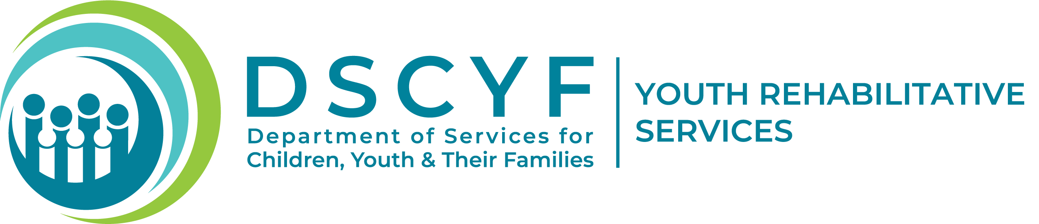

Community Notification Sign-Up Form

The Division of Youth Rehabilitative Services is pleased to be able to provide a community notification system for our surrounding neighborhoods and community.

By completion of this form, you consent to your information to be added to a communication software that will allow the Division of Youth Rehabilitative Services to communicate with you in the event of a youth walk off, youth escape, or any other emergency occurring on the Ferris School campus. The software is a proven communication solution that enables the division to reach any audience, on any device, in any location for critical event management. Please complete the form below and follow the submit form instructions located at the bottom left of this page to submit.
If at any time you move out of the community or choose to no longer receive notification, please contact DYRS by following the opt out instructions located at the bottom right of this page.

Name:

Address Line 1:

City: | State: | Zip Code:
Cell Phone 1: | Cell Phone 2:
Home Phone 1: | Home Phone 2:
Email Address 1: | Email Address 2:
Fax: | Text Phone:

To submit form by mail, email, or fax send to: | To opt out, send removal request to:
DSCYF/DYRS | DSCYF/DYRS
1825 Faulkland Road | 1825 Faulkland Road
Wilmington, DE 19805 | Wilmington, DE 19805
Fax: 302-633-2636 | Or call: 302-633-2620
Email: YRS.DSCYF@delaware.gov | Or email: YRS.DSCYF@delaware.gov

